Poznań, 5 August 2019

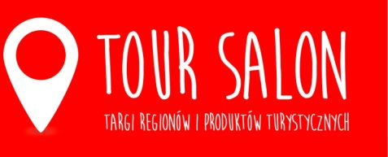

TOUR SALON 2020 in a new space
The 31st edition of the TOUR SALON Fair of Regions and Tourist Products will be held on 14-16 February 2020 in Poznań. Next year, the exhibition will be located
in the Poznań Congress Center in the area of MTP Poznań Expo.
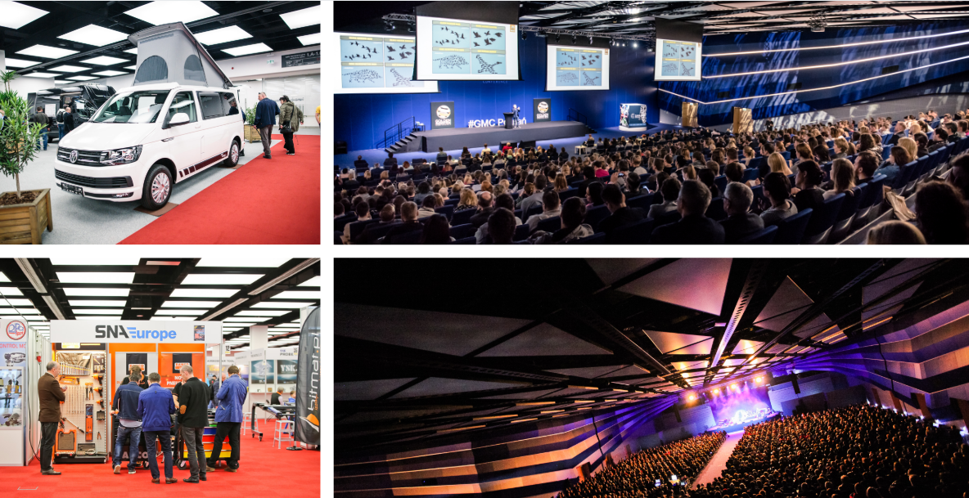
Poznań Congress Center is a modern convention, exhibition and entertainment centre. Its interior, diverse in terms of architecture, enables the organization of various events, from business meetings for a dozen people to events for tens of thousands of participants. Thus it perfectly fits the formula of TOUR SALON, which combines the needs of different groups. On the one hand, there are business meetings of industry representatives organized, and on the other – there is a wide audience that wants to learn more about the regions and attractions worth seeing, verify the offer of travel agencies and meet famous globetrotters to listen about their experience in expeditions to the most remote corners of the Earth.
In 2020, we will satisfy these needs in the modern space of Poznań Congress Center where the exhibition will be located, as well as the zone of meetings with the guests of the TOUR SALON Travellers Festival and the "Following the Trace of Dreams" Travel Festival. The exhibitors will be offered three levels of exhibition space in a very pleasant and modern surrounding. We have also prepared projects of stands taking into account graphical solutions, so important for this type of event and product, i.e. travels. Certainly it will allow us to expose the values of places that will be promoted during TOUR SALON – explains Filip Bittner, Product Group Director.
It is worth noting that in addition to the exhibition space, Poznań Congress Center also offers smaller conference rooms in which industry events planned by the event organizers and partners – conferences, meetings with bloggers – will be held. On one of the levels also a stage will be located, which will host the invited travellers. In the Earth Hall, one of the most modern auditoriums in Poland, the 8th edition of the "Following the Trace of Dreams" Travel Festival will be held.One space, full of emotions, extraordinary adventures and attractions for visitors. It is a perfect solution for a winter weekend and the beginning of holiday dreams – comments Filip Bittner.
The sale of TOUR SALON exhibition space has already started. Remember that promotional prices are valid until 11 October. Exhibitors who register their participation before that date may also take advantage of the promotional activities offered by the event organizer.
For more information visit: www.tour-salon.pl

Media contact:
Katarzyna Świderska, e-mail: katarzyna.swiderska@mtp.pl, phone no.: 691 033 850

